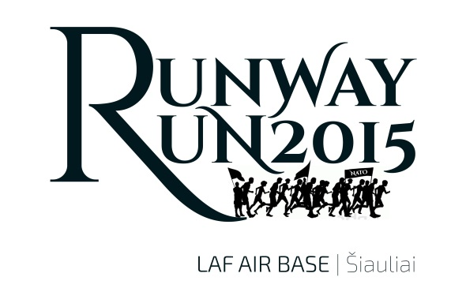
Registration form
“Runway Run 2015” is dedicated to mark 25th Independence Day of Lithuania and 11th Anniversary when Lithuania, Latvia and Estonia became North Atlantic Treaty Organization members and also when NATO took the responsibility for the security of the Baltic Airspace in March 2004. In order to properly thank all participants who support NATO and our effort we kindly ask to fill the form clearly with capital letters.

No. | NATO RANK | NAME, SURNAME | MILITARY UNIT/ORGANISATION  COUNTRY

Registration form
No. | NATO RANK | NAME, SURNAME | MILITARY UNIT/ORGANISATION  COUNTRY

